**Milestone One**

Michael D’Amico

Southern New Hampshire University

CS330 Comp Graphic and Visualization

Jeff Phillips

July 8, 2024

For this project, I chose to create my own scene with items from my house. As suggested, multiple pictures were taken and the following was the chosen picture because it has a good angle on the objects and does not contain any extra clutter.

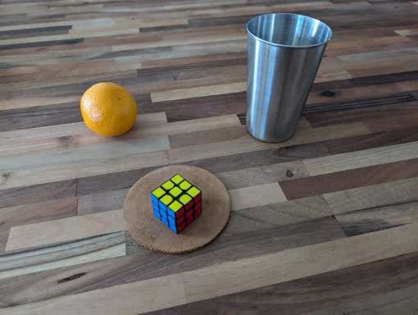

I will be recreating all the objects in this picture, specifically, the orange, the cup, the Rubik cube, and the coaster. These items are all resting on a plane as per the instructions. These items are a good choice because there is complexity and variety with the chosen objects. For instance, the Rubik cube is made up of multiple colored cubes and the cup is a tapered cylinder with a torus shape for the rim. The other objects are simple. First, the object all rest on the a plane (the most basic shape). The coaster will end up being a very flat cylinder and the orange will be a sphere.